Assignment 2
Name: RISHI KUMAR SONI UTA-ID:1001774020

2.1 Task1 Experimenting with Bash Function

$ /bin/bash shellshock
Terminal output

- Using Vulnerable Bash

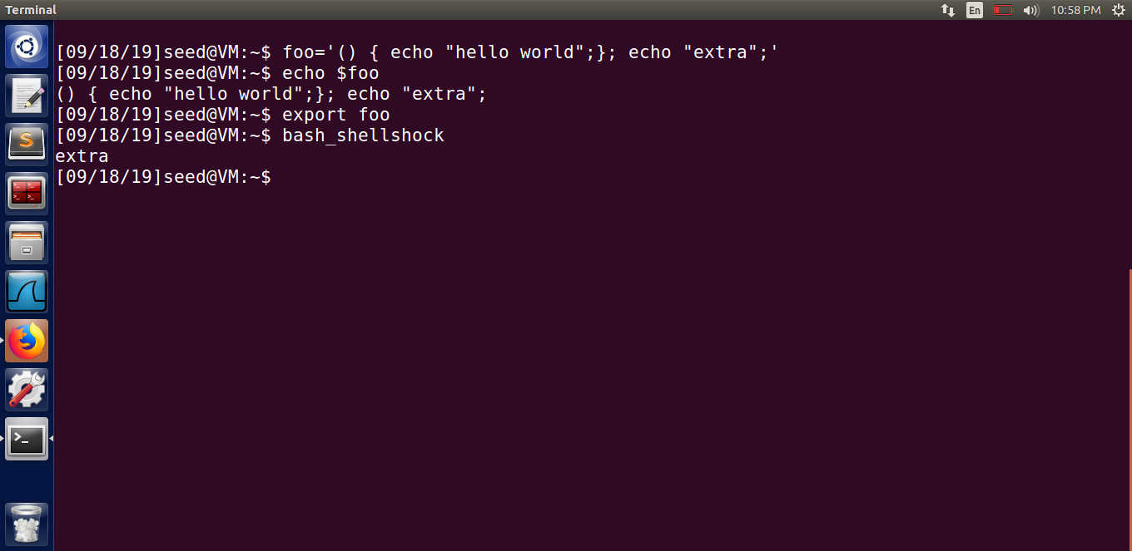

-Non Venerable Bash

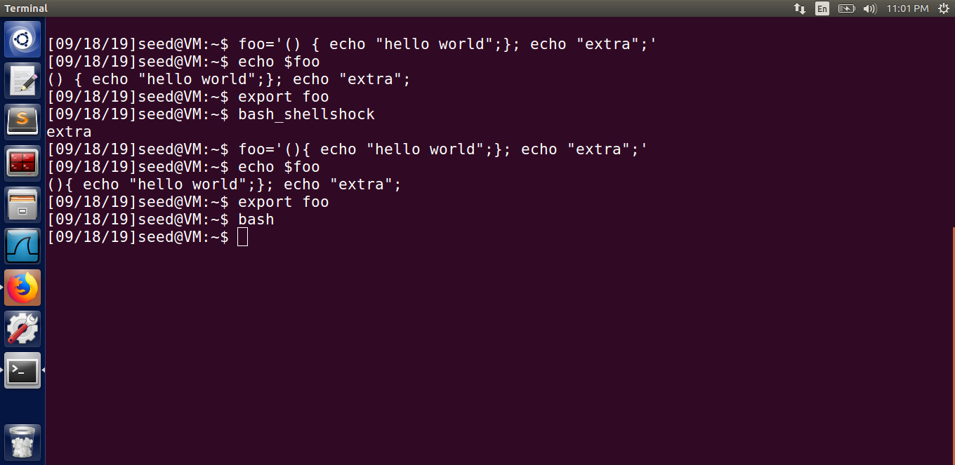

Observation
In Bash Vulnerable Version, the extra line of code is executed contained in the variable is executed.
While in the Non-Vulnerable Bash Version, there is no execution of the extra code in it.

2.2 Task2:: Setting up CGI programs

Cgi Program

#!/bin/bash shellshock
➀ echo "Content-type: text/plain"
echo
echo
echo "Hello World"
Result
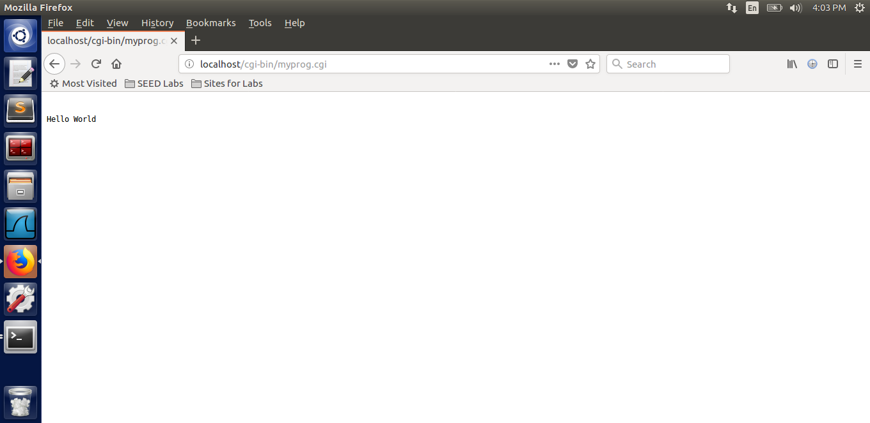

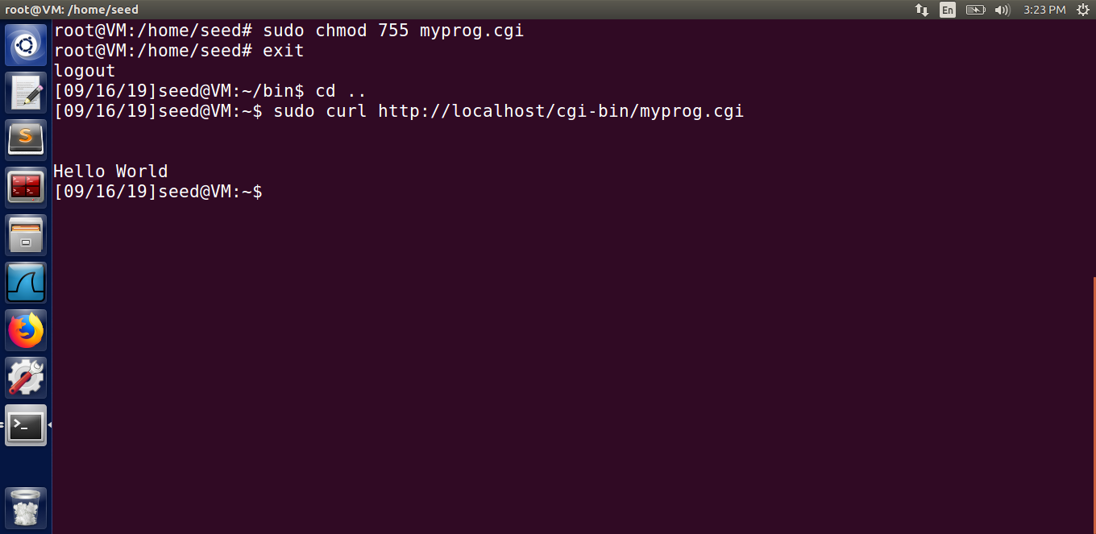

Observation

We create a program myprog.cgi which is a shell script and place it in the folder /usr/lib/cgi-bin which is the default CGI directory for Apache web server. Note that it is only writable under root privileges. We change the permissions of the program to 755 by using the chmod command. We then run the curl command which is a command line tool to access the CGI program from the web which executes the myprog.cgi program and the output is displayed.

2.3 Task3 Passing Data to Bash via Environment Variable
Cgi program

#!/bin/bash_shellshock
echo "Content-type: text/plain"
echo
echo "****** Environment Variables ******"
strings /proc/$$/environ

Result
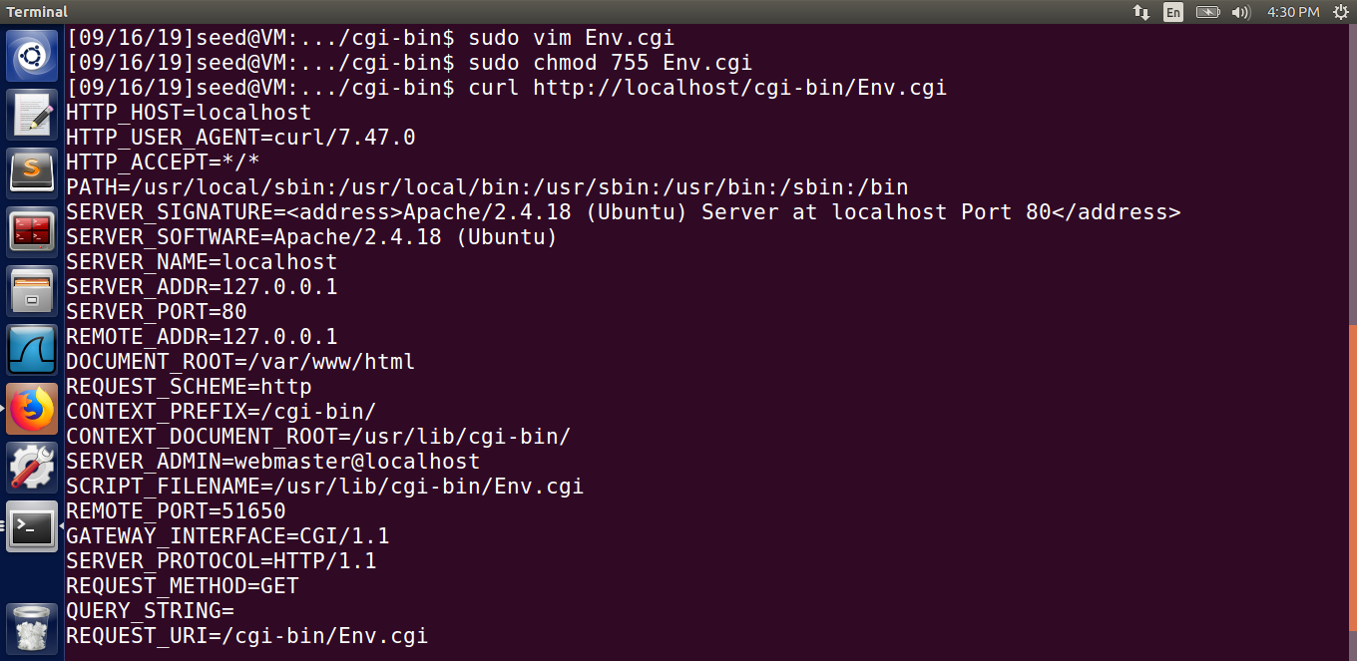
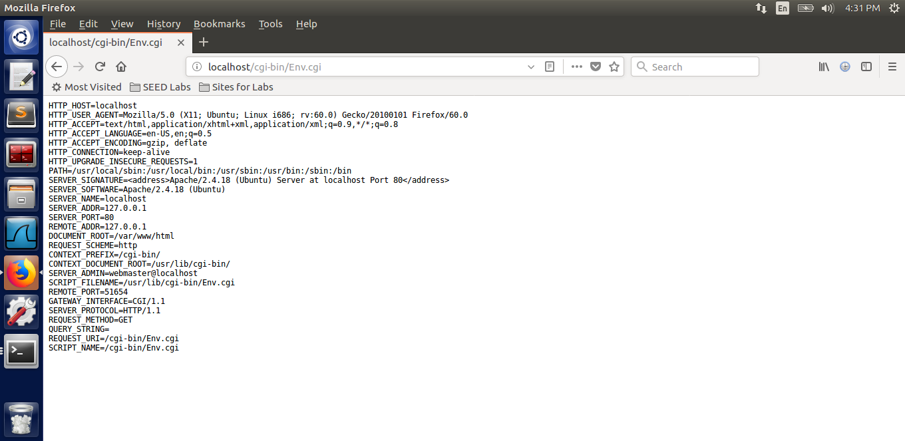

Observation

We create a program Env.cgi which is a shell script and place it in the folder /usr/lib/cgi-bin which is the default CGI directory for Apache web server. Note that it is only writable under root privileges. We change the permissions of the program to 755 by using the chmod command. We then run the curl command which is a command line tool to access the CGI program from the web which executes the myprog.cgi program and the output is displayed.

2.5 Task 5: Getting a Reverse Shell via Shellshock Attack
Attacker Side:
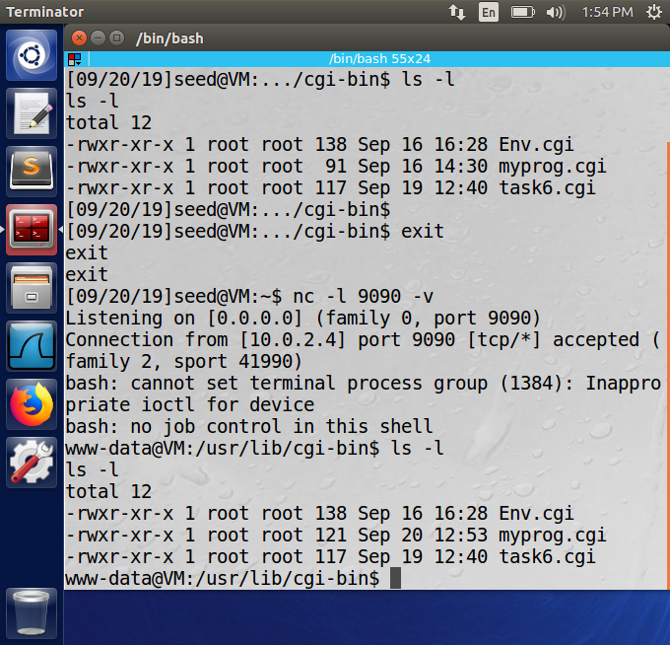

Client Side:
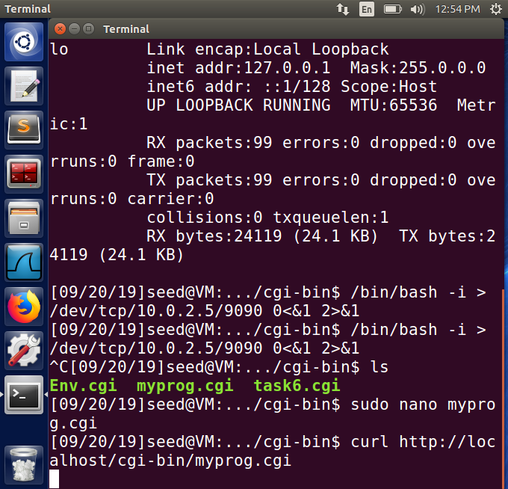
Observation

In one terminal we run the nc command and listen to input connections on port 9090. In another terminal, we run the curl command which calls the interactive bash. After this we get the control of the server’s shell as indicated by the prompt in the listening terminal. Now whatever commands we write will get executed on the server directly.
We attacked the shell shock by using a reverse shell. Reverse shell is basically getting the control of the server with www-data user access. So we get control of all the files accessible to this user by getting access to the user’s prompt.

2.6 Task 6: Using the Patched Bash

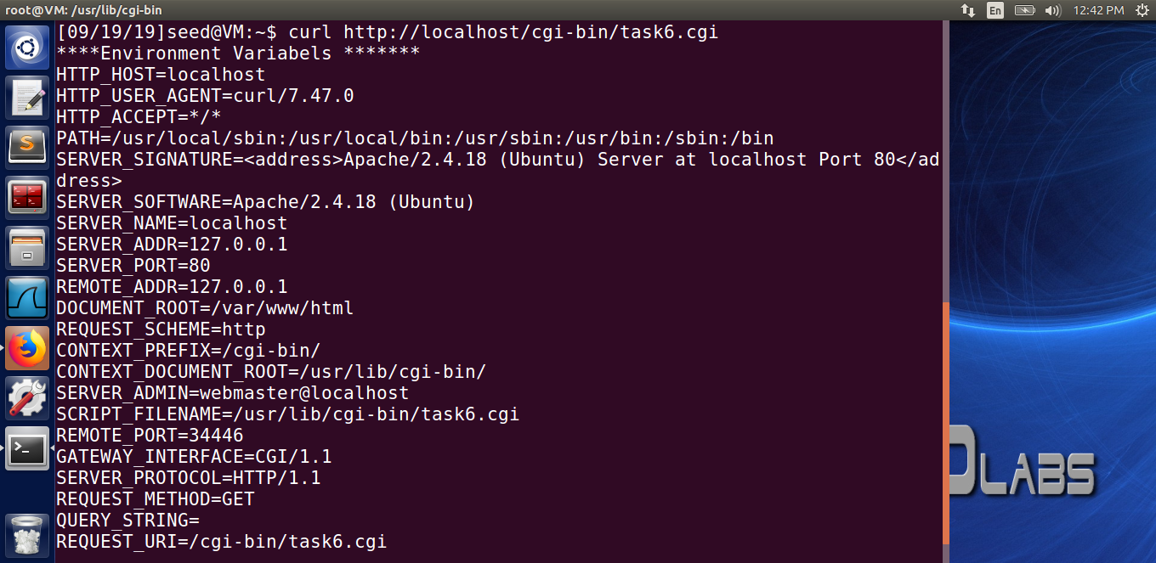

In this experiment we will edit the myprog.cgi file. And we will use #! /bin/bash instead of the #!/bin/bash shellshock .And the observation show there is slightly difference in some of the environment variable of the bash and bash shellshock.
While running the patched version of bash and vulnerable bash there is the difference in the REMOTE_PORT.
Running Reverse Shellshock using Bash Instead Bash shellshock

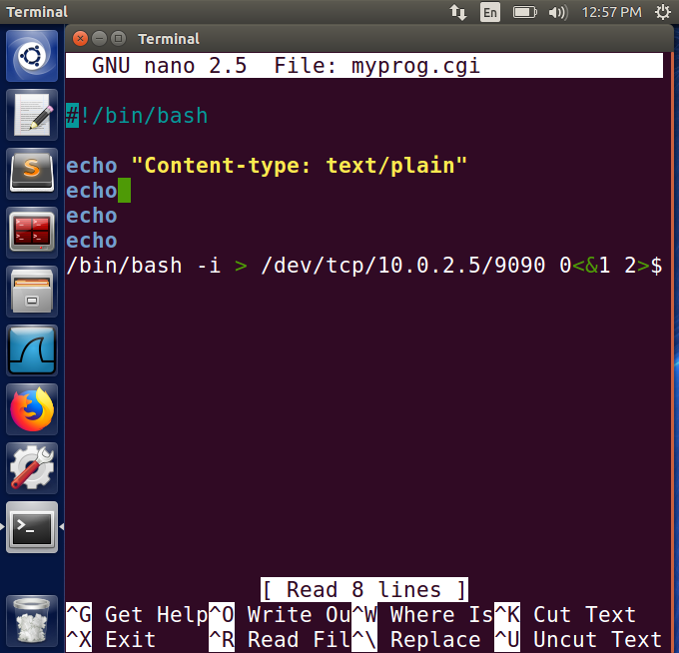

Output:
Client Side
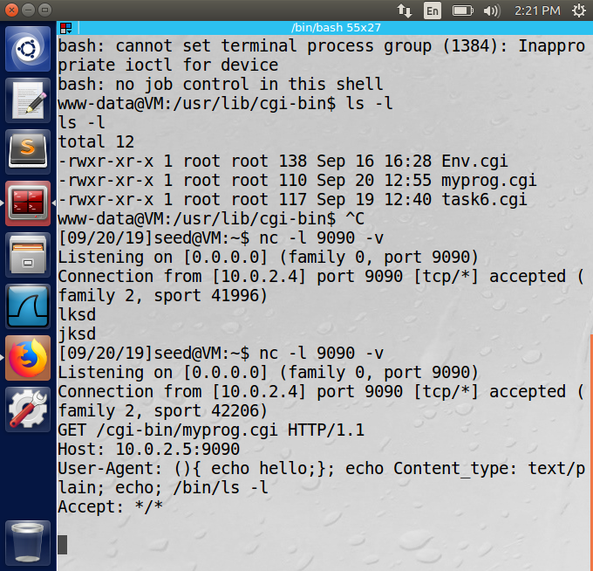
Client Side
